User Acceptance Testing (UAT)
ShopEZ — MERN Stack E-commerce Application

Phase: Project Development Phase
TEAM ID : SWUID2026207177

Classification: Project Documentation — For Academic Submission
User Acceptance Testing (UAT)
1
. Introduction
This document defines the UAT strategy, process, and test cases for the ShopEZ platform. UAT is the final validation phase confirming that the delivered system meets business requirements and is ready for production release.
Live

Application
:
https:
/
/e-commerce-application-neon-
five.vercel.app/
Test

Environment
:

Chrome

v
120+
/
Edge

v
120+ (
desktop

and
mobile

viewports
)
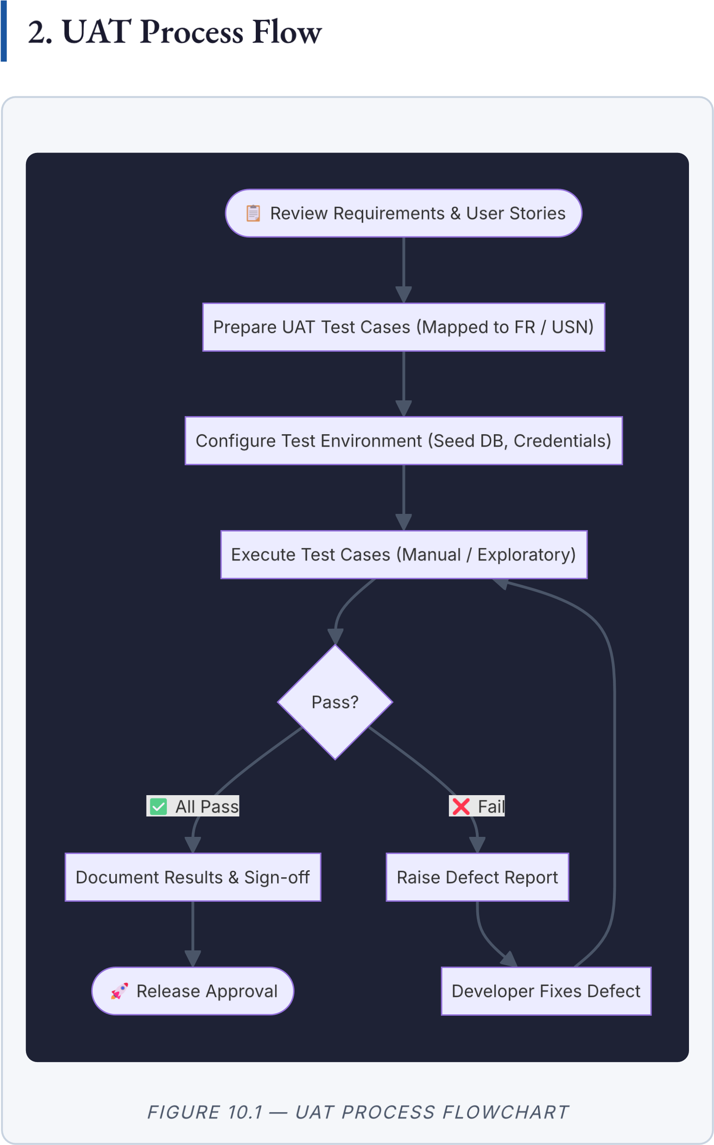

3. Test Credentials
Role | Email | Password
Administrator
admin
@
shopez.com
adminpassword123
Customer
test
@
email.com
password123
4
. UAT Test Cases

4.1 Authentication Module
Test  ID |  | Scenario | Steps | Expected  Result | Status
 | UAT-  001 | New User  Registration | 1. Go to  /register. 2. Enter valid name, email, password. 3.  Submit. | Account created; redirected to dashboard; toast shown. | ☐ Pass  / Fail
UAT-  002 |  | Duplicate  Email  Rejection | 1. Register with an already-used email. 2.  Submit. | Error: "User already exists." Registration prevented. | ☐ Pass  / Fail
 | UAT-  003 | Valid User  Login | 1. Go to /login. 2. Enter valid credentials. 3.  Submit. | JWT set; redirected;  Navbar shows user name. | ☐ Pass  / Fail
UAT-  004 |  | Invalid  Credentials  Rejection | 1. Enter wrong password. 2.  Submit. | HTTP 401;  error: "Invalid email or password." | ☐ Pass  / Fail

4.2 Product Discovery Module
Test  ID |  | Scenario | Steps | Expected Result | Status
 | UAT-  005 | Keyword  Search | - Enter "Shirt" in search bar.  - Press Enter. | Only products containing "Shirt" in name/description displayed. | ☐  Pass /  Fail
UAT-  006 |  | Category  & Price  Filter | - Select  Category =  "Electronics".  - Set Price =  ₹500–₹5,000. | Only Electronics in the price range displayed. | ☐  Pass /  Fail
UAT- Sort Price 1. Select Sort = Products re- ☐
007 Ascending "Price: Low to ordered with Pass /
High". lowest price first. Fail

4.3 Shopping Cart Module
Test  ID |  | Scenario | Steps | Expected Result | Status
 | UAT-  008 | Add to  Cart | 1. Open product page. 2. Select qty=2. 3. Click "Add to Cart". | Cart badge increments; cart shows item with correct qty and total. | ☐ Pass  / Fail
UAT-  009 |  | Update  Cart  Quantity | 1. Open Cart. 2. Change qty of an item. | Subtotal and qty update in real time without page reload. | ☐ Pass  / Fail
 | UAT-  010 | Remove  Item from  Cart | 1. Open Cart. 2.  Click  "Remove". | Item removed; total recalculated; empty cart message if no items remain. | ☐ Pass  / Fail

4.4 Checkout & Payment Module
Test  ID |  | Scenario | Steps | Expected Result | Status
 | UAT-  011 | Full  Checkout  Flow | 1. Add item. 2.  Checkout. 3.  Enter shipping. 4.  Enter test card | Order created; stock deducted; confirmation page shown; | ☐ Pass  / Fail
4242 4242 order in history.
4242 4242 . 5.
Place order.
UAT-  012 | Payment  Failure  Handling | 1. Enter Stripe declined card  4000 0000  0000 9995 at payment step. | Error shown; order NOT created; stock  NOT deducted. | ☐ Pass  / Fail

4.5 Admin Operations Module
Test  ID |  | Scenario | Steps | Expected  Result | Status
 | UAT-  013 | Admin  Product  Creation | 1. Log in as Admin. 2.  Admin →  Products →  "Create". 3. Fill fields & upload image. 4.  Submit. | Product visible in public catalogue; image served from Cloudinary CDN. | ☐ Pass  / Fail
UAT-  014 |  | Admin  Product  Update | 1. Open existing product in Admin. 2. Edit price. 3. Save. | Updated price reflected on public product page. | ☐ Pass  / Fail
 | UAT-  015 | Admin Order  Status Update | 1. Admin → Orders. 2.  Change order status to  "Shipped". | Status update reflected in customer's order history. | ☐ Pass  / Fail
UAT-  016 |  | Unauthorised  Admin Access | 1. Log in as  Customer. 2.  Navigate to  /admin directly. | Access denied; customer redirected with appropriate error message. | ☐ Pass  / Fail

5. Results Summary
Module | Total Tests | Passed | Failed | Pass Rate
Authentication | 4
Product Discovery | 3
Shopping Cart | 3
Checkout & Payment | 2
Admin Operations | 4
Total | 16

6. UAT Sign-Off
Role | Name | Signature | Date
Development Lead
QA Reviewer
Product Owner / Stakeholder
We confirm that the ShopEZ application has been tested against all defined User Acceptance criteria and is approved for production release.

ShopEZ MERN E-commerce Application · Project Development Phase · User Acceptance
Testing (UAT) ·

